***CLOUD COMPUTING***

***TASK 1.1P – RESEARCH REPORT***

1. ***Introduction***

In recent years, cloud computing has revolutionized digital content delivery. Just as services like Netflix and Spotify transformed media consumption, a similar shift is now reshaping the video game industry through cloud gaming. Also known as game streaming, this model runs games on powerful remote servers, streaming live video to users’ devices while receiving their inputs in real time. By offloading processing and graphics rendering to the cloud, high-end gaming becomes accessible even on low-spec hardware.Although cloud gaming has existed conceptually for over a decade, it only gained significant traction around 2019–2020. This growth was driven by the expansion of high-speed internet (including 5G), advancements in cloud infrastructure and GPU virtualization, and consumer demand for instant, on-demand access. The COVID-19 pandemic further accelerated adoption as people turned to at-home digital entertainment.

This report explores the evolution, technology, applications, and future of cloud gaming. Section II outlines its historical development and recent momentum. Section III details enabling technologies, from cloud hardware to edge computing. Section IV reviews motivations and use cases, while Section V examines real-world platforms like GeForce Now, Xbox Cloud, Luna, and Stadia. Section VI highlights benefits for

users and providers, and Section VII addresses challenges such as latency and cost. Section VIII reflects on lessons from failed services like OnLive and Stadia. Section IX evaluates the trend’s five-year outlook, and Section X proposes ways to raise awareness among non-technical peers. Section XI concludes with key insights and future implications.

1. ***Background: Evolution and Recent Rise of Cloud Gaming***

Cloud gaming traces back to the late 2000s and early 2010s, with OnLive (2010) pioneering the concept of streaming high-end games from servers to any device. Despite early buzz, OnLive failed due to low adoption (only ~1,600 peak users), high infrastructure costs from one-to-one server allocation, and limited content. Network latency and bandwidth constraints further hindered user experience. By 2012, the company was insolvent. Gaikai (2011) offered a similar model and was acquired by Sony, leading to the launch of PlayStation Now in 2014. While moderately successful, it remained niche due to its limited library and platform exclusivity.These early efforts revealed that cloud gaming was ahead of its time. Internet infrastructure and cloud tech were not yet capable of delivering the low-latency, high-fidelity experience required. Most limitations—lag, cost, and lack of content—persisted through that era. By 2018–2020, key developments signalled a turning point. Global internet speeds improved significantly with fiber and 4G/5G adoption, while latency dropped. Distributed data centers and CDNs reduced delays. Advances in GPU virtualization and video codecs enabled real-time, high-resolution game streaming. NVIDIA, iterating since 2013, launched GeForce NOW in 2020 as a scalable, robust platform.The entry of Google (Stadia) and Microsoft (Project xCloud) in 2019 brought major resources and visibility. Google aimed for YouTube integration, while Microsoft built on its Xbox ecosystem. Amazon Luna followed in 2020, signaling that cloud gaming had become a strategic industry focus.The COVID-19 pandemic further accelerated adoption as consumers sought home-based entertainment. By 2022, the market had grown to 32 million users and $2.4 billion in revenue, with forecasts predicting $8.2 billion and 87 million users by 2025. What failed in 2010 found fertile ground a decade later—better tech, faster networks, and strong industry support have positioned cloud gaming as a major emerging sector.

***III. Enabling Technologies and Architecture for Cloud Gaming***

Cloud gaming requires a sophisticated blend of hardware, software, and network architecture. Key technologies include:

* High-Performance Cloud Servers with GPU Acceleration:  
  Games are hosted on powerful servers with modern GPUs, often virtualized to support multiple sessions on one machine. NVIDIA, for example, uses dedicated encoding hardware (NVENC) to render and stream games in real time. Efficient video codecs like H.264, H.265, and AV1 reduce bandwidth use and latency. Virtualization also boosts scalability, unlike early platforms like OnLive, which required one server per user.
* Low-Latency Network Infrastructure & Edge Computing:  
  Network speed is crucial—latency must stay under ~50–70 ms for smooth gameplay. 5G and fiber broadband provide the bandwidth needed for HD/4K streams. Services use edge computing and CDNs to bring servers closer to users, minimizing delay. For example, GeForce Now operates across multiple continents, ensuring most users connect to nearby data centers. Custom streaming protocols like WebRTC also reduce lag.
* Game Streaming Software and Protocols:  
  Cloud gaming stacks include server-side game logic, real-time video encoding, and thin clients on user devices. Adaptive bitrate streaming adjusts quality based on internet conditions. Protocols like WebRTC support low-latency video + input transfer. Some systems even predict user actions or buffer a few frames ahead to mask lag. DRM is embedded since only video is streamed, protecting content from piracy.
* Scalable Multi-Tenant Architecture:  
  Platforms manage thousands of game sessions using orchestration tools that spin up containers or VMs dynamically. Auto-scaling handles usage spikes. Services often adopt microservices architecture for flexibility—separating authentication, game management, matchmaking, and streaming. They may use AWS or Azure for compute and global reach. Redundancy and failover systems keep sessions live during outages.

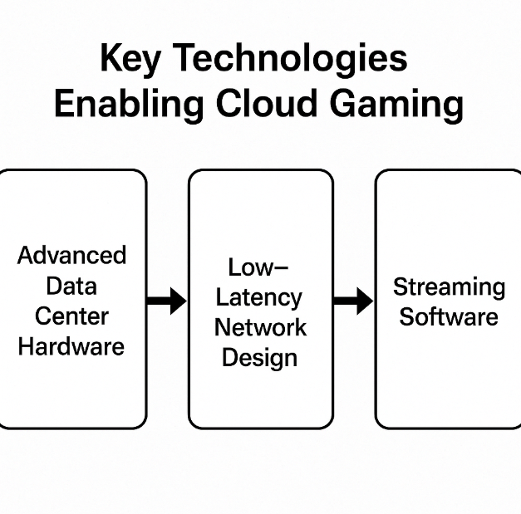

***IV. Motivations and Applications Driving Cloud Gaming***

Cloud gaming is gaining momentum due to several strong motivations and real-world use cases:

* Wider Accessibility:  
  Cloud gaming removes the need for expensive hardware, making high-end games playable on basic laptops, smartphones, or tablets. Users can seamlessly switch between devices—starting on a TV, continuing on a phone—mirroring how we stream media across platforms. This lowers barriers and expands the gaming audience.
* Instant Play and On-Demand Content:  
  Games can be played immediately—no downloads, installs, or updates. This enables demo-style experiences from ads or YouTube links, letting users jump straight into gameplay. For publishers, it means quicker exposure and potential conversions.
* Platform-Agnostic Delivery:  
  Games hosted in the cloud can run on any device without needing multiple ports. Developers benefit from lower costs and broader reach. Services like NVIDIA’s GDN allow direct-to-user streaming via browsers or apps, bypassing traditional storefronts.
* Subscription-Based Monetization:  
  Services like Xbox Game Pass and PS Plus Premium offer streaming access to large libraries. This model provides recurring revenue, improves DRM control, and extends a game's life—even letting users play titles from older consoles they no longer own. Telecoms also see it as a reason to promote faster 5G plans.
* New Interactive Possibilities:  
  Cloud-hosted multiplayer games can scale up to large synchronized environments. Events like virtual concerts in games (e.g., Fortnite) streamed via the cloud blur the lines between gaming and entertainment, enabling real-time, shared experiences across devices.

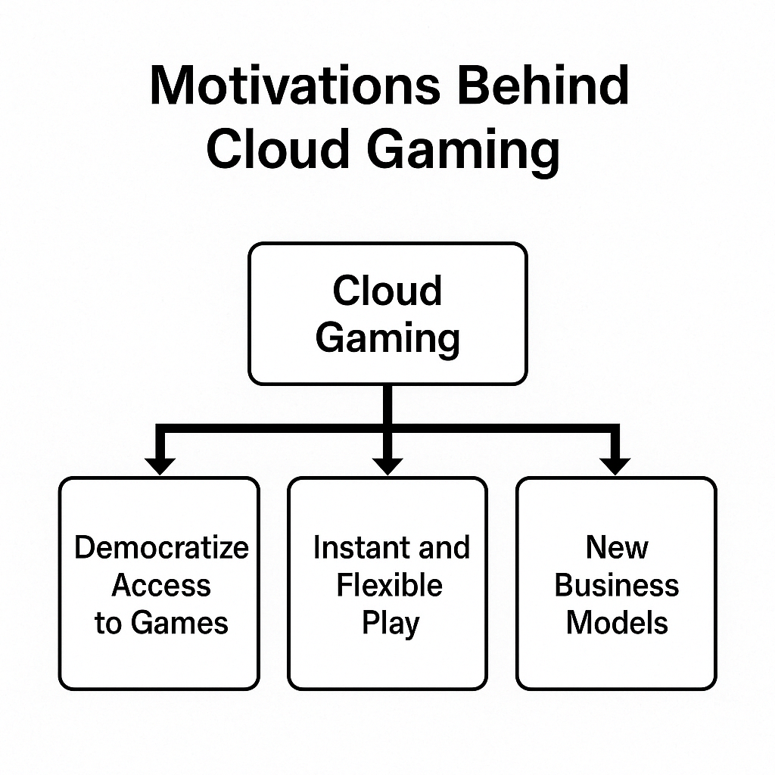

***V. Cloud Gaming Platforms and Real-World Examples***

Several cloud gaming platforms have emerged, each offering a distinct approach to streaming games:

* NVIDIA GeForce Now:  
  Officially launched in 2020, GeForce Now lets users stream games they already own from stores like Steam or Epic. It runs on NVIDIA’s powerful cloud GPUs and supports up to 4K60 streaming for premium users. With over 25 million users by 2023, its success lies in supporting existing libraries and delivering high performance. The “Ultimate” tier leverages RTX 4080 servers for ray tracing and 120 fps gaming.
* Xbox Cloud Gaming (xCloud):  
  Integrated into Xbox Game Pass Ultimate, Microsoft’s platform streams a wide catalog of Xbox games across PCs, mobile devices, browsers, and Xbox consoles. It runs on Xbox hardware hosted in Azure data centers. Over 10 million users had streamed by 2022. Features like mobile touch controls and integration with existing Xbox ecosystems broaden its appeal.
* Google Stadia (Shutdown 2023):  
  Stadia ran on Google Cloud with support for 4K HDR streaming and YouTube integration. However, it struggled due to limited content, high pricing, and no standout exclusives. Its shutdown highlighted that strong infrastructure alone isn't enough—content strategy and value matter. Still, Stadia proved that large-scale cloud gaming was technically feasible.
* Amazon Luna:  
  Launched in 2020, Luna uses a channel-based subscription model (e.g., Ubisoft channel, Family channel). Running on AWS EC2 G4 instances, it streams up to 1080p60 (4K for some games). Luna is integrated with Twitch and compatible with Fire TV and smart devices. Though cautious in its rollout, Luna targets casual gamers and showcases Amazon's cloud potential.
* Sony PlayStation Cloud Streaming:  
  Sony transitioned from PS Now to include cloud streaming in its PlayStation Plus Premium tier. Users can stream hundreds of PS3, PS4, and some PS5 games to consoles and PCs. Its mobile and regional limitations keep it supplementary to Sony’s hardware model, focusing mainly on backward compatibility.
* Other Services:  
  Providers like Shadow offer full cloud PCs for gaming, while Boosteroid and Blacknut cater to niche markets, including regional access and family content. Telecoms are also entering the space via white-label solutions and partnerships (e.g., Ericsson reports 35 telco cloud gaming launches by 2022). Even Netflix and game engines like Unity are exploring this space.

***VI. Benefits to Consumers and Implications for Providers***

Cloud gaming offers significant advantages to both consumers and service providers:

Benefits for Consumers

* No Expensive Hardware:  
  Users can play high-end games on basic devices like tablets or old laptops. Processing is done in the cloud, eliminating the need for regular hardware upgrades.
* Play Anywhere, Seamlessly:  
  Game progress is saved in the cloud, enabling smooth transitions between devices—TV at home, smartphone on the go, or PC at work.
* Instant Access & Variety:  
  Games load instantly—no downloads or installs. Subscription models allow easy switching between titles and genres, enhancing game discovery and convenience.
* Reduced Cheating & Piracy:  
  Since games run on secure servers, cheating is harder and piracy is minimized. This creates a fairer online environment and better IP protection for developers.

Implications for Providers

* New Revenue Streams:  
  Cloud gaming drives demand for subscriptions and cloud resource usage. Bundling with services (e.g., Xbox Game Pass, mobile data plans) helps lock users into ecosystems.
* Asset Leverage:  
  Companies like Microsoft and Amazon combine infrastructure (Azure, AWS) with content (Xbox, Twitch) to maximize reach and revenue. NVIDIA uses GeForce Now to showcase its GPU capabilities.
* Shifting Industry Power:  
  Publishers can bypass consoles by streaming directly to users. As a result, cloud providers may acquire studios or secure exclusive rights—reshaping industry dynamics.
* Global Expansion:  
  Cloud gaming can reach underserved regions with strong mobile networks but few consoles. China’s 5G rollout, for instance, is accelerating mobile-first gaming access.
* Service-Based Engagement:  
  Cloud gaming supports continuous delivery—regular updates, events, and flexible pricing. This “gaming-as-a-service” model builds ongoing relationships with users.

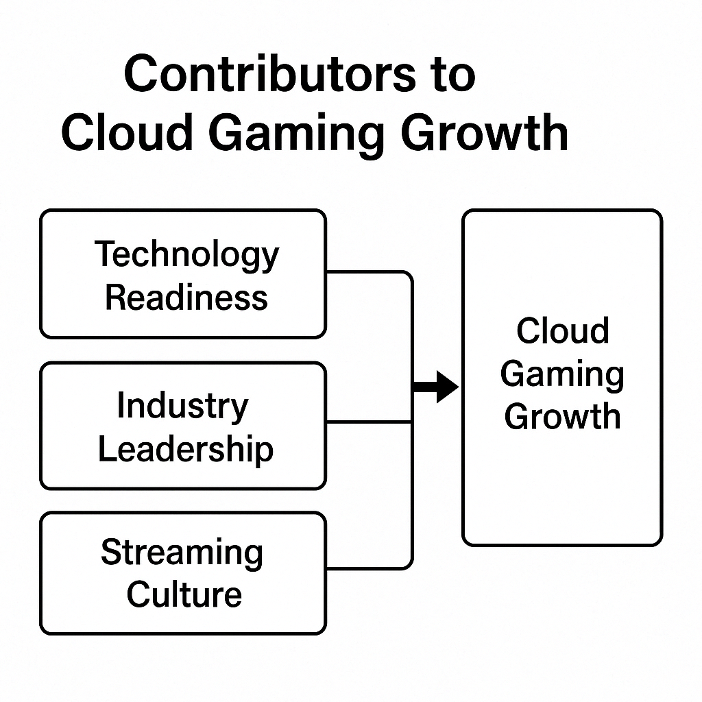

***VII. Challenges and Limitations of Cloud Gaming***

Despite its potential, cloud gaming faces several key hurdles:

* Latency and Network Dependency:  
  Gameplay relies on ultra-low latency (~50–70 ms). Inconsistent internet, jitter, or slow connections can lead to lag, especially for fast-paced games. Unlike local gaming, cloud gaming is unusable without internet—even for single-player titles.
* High Bandwidth Usage:  
  HD and 4K game streaming can consume 5–20 GB/hour. This strains data caps and home networks. For frequent gamers, monthly data usage may exceed 1 TB—unfeasible in many regions with bandwidth limits.
* Costly Infrastructure for Providers:  
  Running and scaling GPU-rich cloud servers is expensive. Providers must balance usage with cost via smart virtualization and regional data centers. High streaming traffic also incurs cloud egress fees, challenging profitability for smaller services.
* Inconsistent Quality and Compression Artifacts:  
  Fluctuating bandwidth can degrade visuals—dropping resolution or causing blocky graphics during fast motion. Premium features like 4K and 120 fps are often locked behind high-tier subscriptions.
* Limited Game Libraries and Licensing Issues:  
  Not all publishers support streaming. Licensing disagreements (e.g., with GeForce Now) can lead to title removals. A lack of exclusives or a fragmented library can reduce service appeal.
* User Skepticism and Adoption Gaps:  
  Some gamers prefer local ownership or fear service shutdowns (e.g., Stadia). Cultural resistance to subscriptions and reliance on cloud persists, especially among traditional PC/console gamers.
* No Modding or Custom Tweaks:  
  Cloud platforms restrict user access to files, preventing game mods and custom settings. This may alienate PC gamers who value personalization and performance tuning.
* Privacy and Security Concerns:  
  All gameplay data is hosted remotely. Users must trust providers with personal data and game progress. A breach or cloud failure could result in permanent data loss.

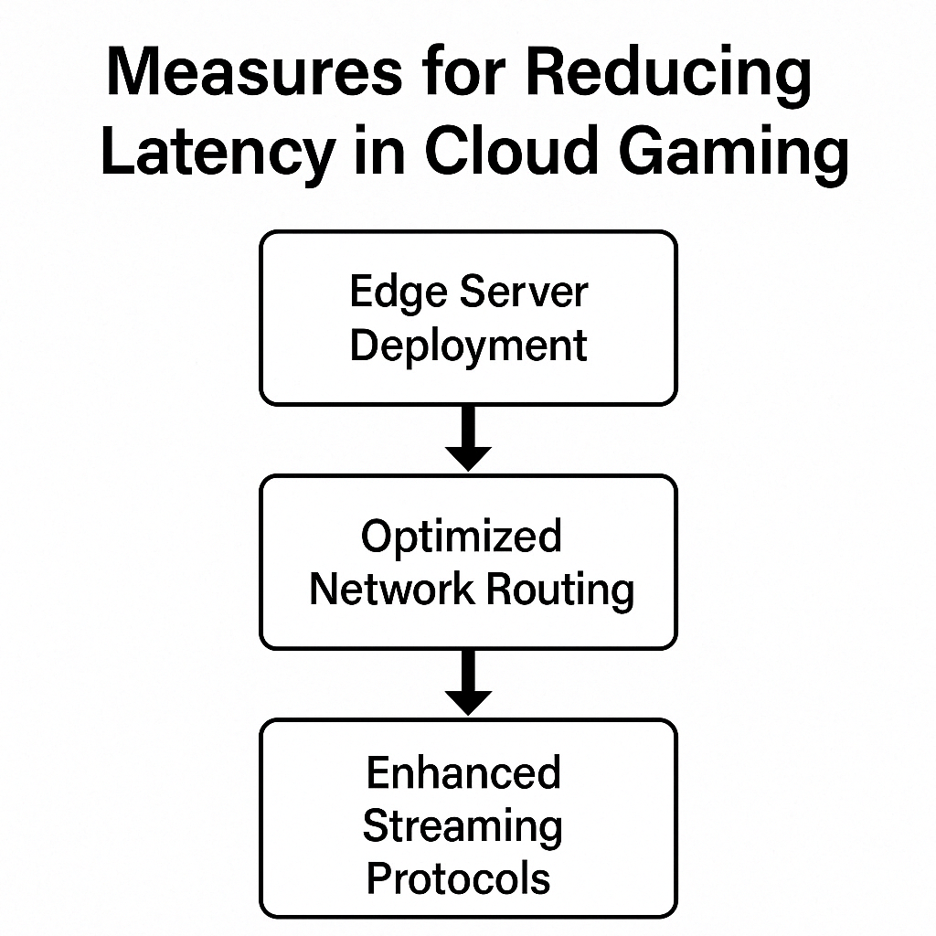

***VIII. Lessons from Past Attempts vs. Present Initiatives***

Past failures like OnLive and Stadia offer valuable lessons that current platforms are actively applying:

* Technology Readiness:  
  OnLive struggled due to weak broadband, limited GPU power, and poor compression tech. Today’s platforms benefit from 5G, fiber, powerful GPUs, and adaptive bitrate streaming. What was barely feasible in 2010 is now technically practical and scalable.
* Content Strategy & Business Model:  
  Stadia and OnLive expected users to repurchase games. In contrast, Xbox Cloud and GeForce Now integrate with existing libraries or subscriptions (Game Pass), reducing friction. Gamers want large libraries and familiar content—not to re-buy or start over.
* Scalability & Cost Efficiency:  
  Early platforms used one GPU per player, making scaling expensive. Today, GPU virtualization and cloud orchestration allow multiple sessions per server. Tech giants can absorb early losses, unlike startups like OnLive.
* Market Timing & Consumer Mindset:  
  In 2010, digital streaming and subscriptions were still new. By 2020, users had embraced Netflix-like models. Rising hardware prices and shortages also make cloud alternatives more appealing today than before.
* Trust & Platform Longevity:  
  Stadia’s abrupt shutdown hurt consumer trust. In contrast, Microsoft, Sony, and NVIDIA have long-standing reputations in gaming, offering reassurance that services like xCloud and GeForce Now are here to stay.
* Iterative Development:  
  Unlike OnLive’s “all-at-once” approach, modern platforms launched in beta (e.g., xCloud, GeForce Now) and improved steadily. This allowed feedback-driven enhancements and more reliable user experiences.

***IX. Future Outlook: Cloud Gaming (2025–2030)***

Cloud gaming is poised for steady growth in the next five years, though full replacement of local gaming remains unlikely.

* Mainstream Growth:  
  Market projections estimate the industry will surpass $8B by mid-decade. Cloud gaming will become a standard option, integrated into smart TVs, consoles, and mobile ecosystems. Awareness and adoption could approach universal levels by 2030, with hundreds of millions of users.
* Advancing Technology (5G, Edge, Hardware):  
  Broader 5G and fiber access will reduce latency, while AV1/AV2 codecs and future GPUs will support smoother 4K/8K streaming. Edge computing expansion will place cloud nodes closer to users, enabling near-native performance—even for VR or competitive games.
* Hybrid Ecosystem – Not a Full Replacement:  
  Cloud gaming will coexist with local hardware. Consoles and gaming PCs will remain relevant, especially for offline and high-performance use. Cloud will serve casual, budget, and portable use cases. Expect hybrid consoles with both local and cloud play options.
* Integration with VR/AR & Metaverse:  
  Cloud rendering will support lightweight VR/AR devices. Cloud platforms may power persistent online worlds (metaverse-style), enabling access from any device. However, ultra-low latency remains a challenge for VR and will depend on edge/5G maturity.
* Competition & Consolidation:  
  Fewer dominant platforms are likely to emerge, tied to ecosystems (Xbox, PlayStation, NVIDIA, etc.). Smaller services may be acquired or sunset. Publishers and telecoms may also enter the market. Expect more bundled offerings and Netflix-style subscriptions.
* Success Indicators:  
  Signs of success include major game launches available day-one via cloud, and increased cloud gaming adoption in emerging markets. Telcos in Asia and Africa may drive this shift, using 5G to reach new audiences where consoles are rare.

***X. Promoting Cloud Gaming Awareness and Adoption***

To broaden cloud gaming adoption, especially among non-technical users, the following strategies can help:

* Simple Analogies:  
  Use relatable terms like “Netflix for games” or “interactive YouTube” to explain how cloud gaming works—streaming games from the cloud, just like movies or music.
* Live Demonstrations:  
  Let people try it out—show how high-end games run smoothly on low-spec devices. Demos help convert skeptics who need to “see it to believe it.”
* Highlight Benefits, Not Specs:  
  Emphasize convenience: “No console needed,” “Play instantly,” “Use your current devices.” For students: “Game on your laptop after class—no gaming rig required.”
* Address Concerns Honestly:  
  Acknowledge issues like data use or internet speed, but explain how newer tech (e.g., better codecs, 5G) makes cloud gaming viable for many. Share real-life usage examples for credibility.
* Peer Testimonials:  
  Encourage those who’ve tried cloud gaming to share experiences. Word-of-mouth and social proof from friends or classmates boosts interest and trust.
* Engage Gaming Communities:  
  Post facts or infographics in Discord servers, forums, or clubs. Example: “Did you know you can play AAA games on a Chromebook using cloud gaming?”
* Use Events to Showcase:  
  Set up a cloud gaming station during orientation week, tech fairs, or gaming events to attract passersby and offer hands-on experience.

***XI. Conclusion***

Cloud gaming marks a transformative shift in how games are delivered and played—streaming high-quality titles directly to any device via the cloud. Enabled by advancements in internet speeds, GPU power, and video codecs, it eliminates the need for expensive hardware, making gaming more accessible and flexible. While services like GeForce Now and Xbox Cloud show real promise, challenges like latency, data usage, and content licensing remain. Lessons from past failures highlight the need for the right tech, strategy, and user trust. As 5G, edge computing, and user education evolve, cloud gaming is set to grow alongside traditional platforms, redefining interactive entertainment and pushing the boundaries of cloud infrastructure.

***References***

1. Ericsson, “5G opportunities in the cloud gaming market,” *Ericsson Mobility Report*, Dec. 2022.

**Website:** https://www.ericsson.com

1. Datacenters.com, “The Rise of Cloud Gaming is Accelerating in 2023,” Sep. 20, 2023. https://www.datacenters.com/news/the-rise-of-cloud-gaming-is-accelerating-in-2023
2. Deloitte Insights, “Cloud gaming and the future of social interactive media,” Deloitte, 2021. https://www2.deloitte.com/us/en/insights/industry/technology/cloud-gaming.html
3. Supermicro & Intel, “Cloud Gaming Solutions – Architecture and Requirements,” *Solution Brief*, Aug. 2022. https://www.supermicro.com/en/solutions/cloud-gaming
4. Game World Observer, “What does the end of Stadia mean for cloud gaming?” Nov. 29, 2022. https://gameworldobserver.com/2022/11/29/what-does-the-end-of-stadia-mean-for-cloud-gaming
5. The Verge, “OnLive lost: how the paradise of streaming games was undone,” Aug. 28, 2012. https://www.theverge.com/2012/8/28/3277792/onlive-steve-perlman-cloud-gaming-history
6. LEVVVEL, “How many people use GeForce Now? — 2025 statistics,” May 11, 2023. https://levvvel.com/how-many-people-use-geforce-now-statistics/
7. 9to5Google, “Xbox Cloud Gaming has over 10 million players,” Apr. 2022. https://9to5google.com/2022/04/01/xbox-cloud-gaming-10-million-players/
8. Statista, “Cloud gaming - statistics & facts,” Apr. 2022. https://www.statista.com/topics/8062/cloud-gaming/
9. Datacenters.com, “The Benefits of Cloud Gaming,” 2023. https://www.datacenters.com/news/the-benefits-of-cloud-gaming
10. NVIDIA Technical Blog, “Revolutionizing Cloud Gaming with NVIDIA GDN,” 2023. <https://developer.nvidia.com/blog/revolutionizing-cloud-gaming-and-graphics-rendering-with-nvidia-gdn/>
11. PC Gamer / Ars Technica, “Stadia 4K streaming data usage,” Oct. 2019. (Reports on data consumption rates for Google Stadia at various resolutions, e.g. ~15 GB/hr at 4K) (https://www.pcgamer.com/stadia-4k-streaming-will-use-up-1tb-of-data-in-65-hours/